Campfire Ashes
Ceremony

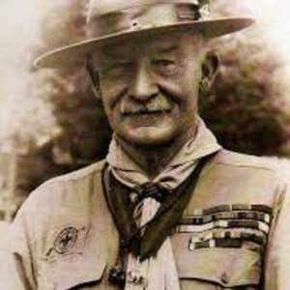

Lord Baden-Powell was the father of the Scouting movement
In 1907, on Brownsea Island in England, he conducted the first Scout Camp for Boys. At the end of that camp, he gave some of the ashes from the campfire to each of the boys and kept some for himself.
Baden-Powell would always take a small amount of ashes from a ceremonial campfire and then spread these ashes into the next campfire. The main purpose of these ashes is to share with you the memories of past campfires and to bring to all Scouts and Scouters, the International aspect of the World Brotherhood of Scouting.
(Only those attending the campfire would receive the ashes).

Will anyone with ashes please come forward and join me(us)?

The ashes I(we) will spread into this campfire carry memories of past campfires dating back to Brownsea Island, England in July of 1907, the First Boy Scout Camp. They have been carried all around the world to over 700 Scouting Campfires in all 50 states and 40 countries where Scouting Fellowship has been shared.

I will now read the words of Lord Baden-Powell to charge these ashes to this campfire.
“We carry our Friendship with us in these ashes from other campfires with comrades from other lands. May the joining of the past fires with the leaping flames of this campfire, symbolize once more, the unbroken chain that binds Scouts and Guides of all nations together. With Greetings from our brothers and sisters around the world, I add these ashes and the Fellowship therein to our campfire.”

The Story of the Campfire Ashes

One of the many interesting traditions in Scouting is that of the campfire, and of it’s ashes. After a campfire, ashes may be collected and distributed to the participants. At a future campfire, the ashes are added to the fire to ensure continuity of the spirit of Friendship and Warmth of the campfire and of Scouting. A list of the fires is maintained which are so represented.
This sample of ashes has a proud heritage, starting in 1907 on Brownsea Island in England. Lord Baden-Powell was present at the time.
These ashes have taken part in campfires all over the world, including a 1965 Camporee in Canada where Lady Baden-Powell lit the fire, and the 2007 World Jamboree in England celebrating the 100th anniversary of Scouting. Numerous Wood Badge, NYLT Courses, and Order of the Arrow Ceremonies are represented, as well as many World and National Jamborees along with various other Scouting functions and events.
The countless thousands of participants that have shared these Campfires of Friendship and Warmth include Boy Scouts, Cub, Webelo, Venture, and Sea Scouts, Girl Scouts along with their leaders and guests.
Scouting is an international movement which has flourished over the many years because its spirit is important in millions of lives. May the spirit of Scouting be important in your life, and like these ashes, keep itself alive by being passed on to others.

50 States, 41 Countries, 703 Campfires

